E-Library Management System

Overview:

Description of real-world system ………………………………………page 2.

**Structured analysis**

System Non-Functional Requirements……………………………………page 3.

System Functional Requirements……………………………………………page 4.

**Structured design**

Data Flow Diagram Level 0…………………………page 5.

Data Flow Diagram Level 1…………………………page 6.

Data Flow Diagram Level 2…………………………page 7.

Logical ERD…………………………………………………page 8.

Description of real-world system

The electronic library management System is a computerized System which helps librarians to manage the library daily activities. It reduces the work on paper which prevents File Loss and time consumption. To start with, the user logs in with his username and password. If the user does not have an account, the system gives an option to the user to create an account.

There are 2 types of logins, the user login, and the admin login. Admin logins refers to teachers as they have the right to add or remove their tutorials, books and pdfs. On the other hand, user login refers to students. Students have the option to search, watch tutor tutorials, and save to favorites.

Moreover, a database will be used to store records of books and users. MYSQL will be used as a database management system. This is used to retrieve records using simple queries (in English statements) , which are easy to understand and easy to write.

The database can be used in both input/outputs when log-in is done, the system asks the user for username and password (input) and checks if they are correct, it also gives the ability to search for certain items in the database through queries and filters (output).There will be a database that will store tutorial videos.

System Requirements

1. Non-Functional Requirements.

* Efficiency Requirement.
  + When implementing the library management system, teachers and students will easily access the E-Library as searching and book transaction will be faster and requires less effort.
* Reliability Requirement.
  + The system should accurately perform operations such as member account registration, member validation, book transaction and search.
* Usability Requirement.
  + The system should be user-friendly so that the student and teacher can easily perform various tasks.

1. Functional Requirements.

User Login

* 1. When they register, they are given a user id.
  2. Only users with a valid id and password should be able to access the device.
  3. The system goes through an authorization process to determine which user levels have access to what information.
  4. After the user has finished using the system, they must be able to logout.

Register new user

* 1. Data must be checked by the system.
  2. When data is incorrect, the system must be able to erase it.

Register New Materials (Books, videos and Pdfs)

* 1. The system should be able to input the number of book copies into the table.
  2. The system must be able to distinguish between two books with the same book id.
  3. Teachers have the capability to remove or add materials at any time.

Search Materials (Books, videos and Pdfs)

* 1. The system should be able to scan the database using a variety of search types.
  2. The system must be able to filter materials (Books, videos and Pdfs) by entering a keyword.
  3. The system should be able to display the filtered materials (Books, videos and Pdfs) in a table format.

Data Flow Diagrams

1. Level 0:

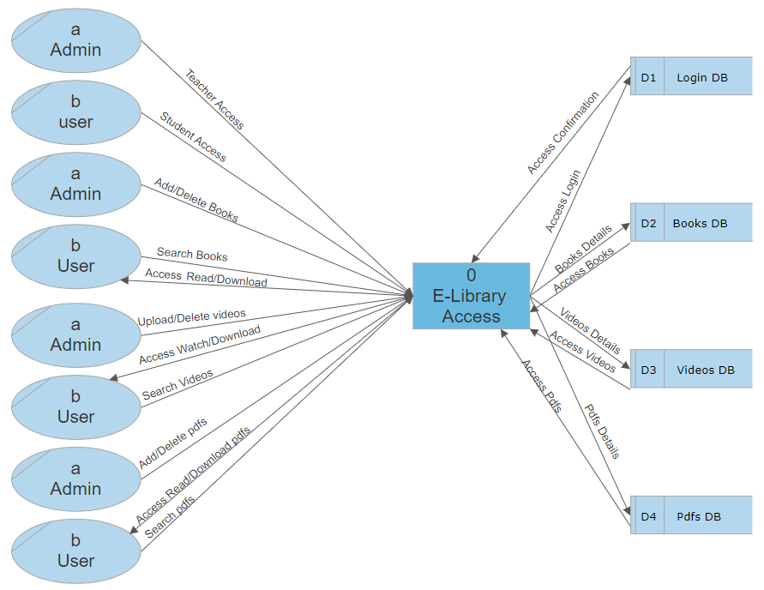

1. Level 1:

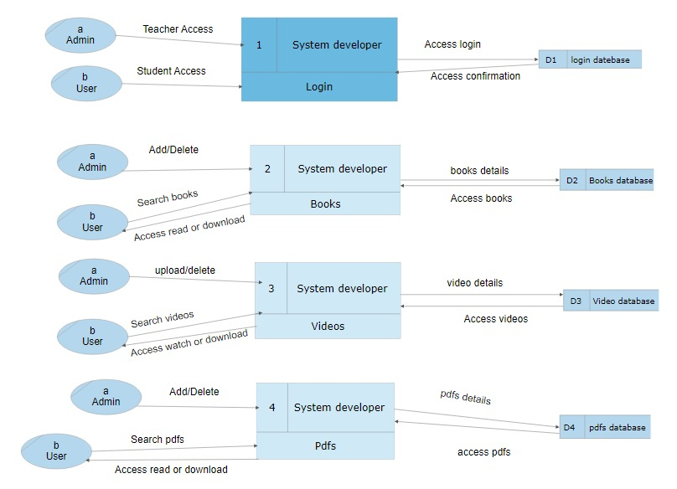

1. Level 2:

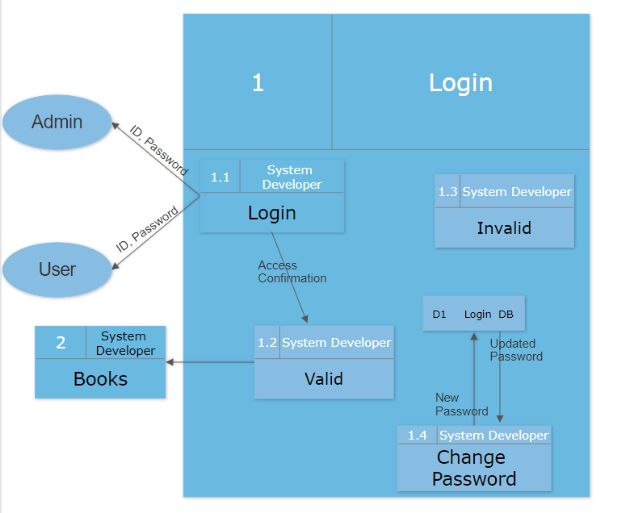

1. Logical ERD:

